

-RETURN, EXCHANGE AND CANCELLATION POLICY

---RETURN & EXCHANGE POLICY

* Easy return and exchange for any manufacturing defect.
* Customers can return their order within 2 days of delivery in an unused condition of the merchandise with all tags.
* We guarantee the standard, as all items in our brand is from our own manufacturing facility.
* We still don't have a reverse pickup facility yet then you’re requested to ship the product(s) back to us. Please pack the things securely to stop any loss or damage during transit.

---REFUND POLICY

* After we’ve received the product(s) and a top-quality check is completed, the merchandise amount is going to be credited back to you as reward points/gift cards for an equivalent amount (except shipping charges).
* The amount will only be refunded as a gift card for any cancelled/returned order. No Claims for online refunds are going to be entertained.

---CANCELLATION  POLICY

* Any order is often cancelled within 24 hours of order placement.
* We won’t be to able cancel your order if its already been dispatched.

-SHIPPING AND TRACKING POLICY

* We assure you that our customers get one among the simplest experiences of online shopping that's carefree and dependable. We lookout of all parameters that ensure your order reaches you during a sound state.
* All our orders are predicted to be delivered within 6-7 working days. However, the delivery time may vary consistent with the shipping address.
* Note– Just in case, you receive the merchandises with the outer packaging tampered don't accept the product, or please make a note regarding an equivalent in proof of delivery given by courier boy for signing before signing an equivalent.

-KEY POINTS

---MADE IN INDIA: Project AATMA-NIRBHAR BHARAT

---VALUE FOR MONEY: Best Quality at an affordable rate

-ABOUT US

* We are a quality clothing brand for men and women garments. The majority of our products are 100% cotton keeping in mind the Indian weather as we are an Indian brand with international quality inspired by ATMA NIRBHAR BHARAT Abhiyan of Indian Government.
* The manufacturing facility is taken care of by textile professionals having more than 30 years of experience in fabric manufacturing which gives us an edge in the quality of our garment.
* We are committed in giving the latest fashion with quality at a modest rate.

-CATEGORIES:

 ---MEN

* COTTON DENIM

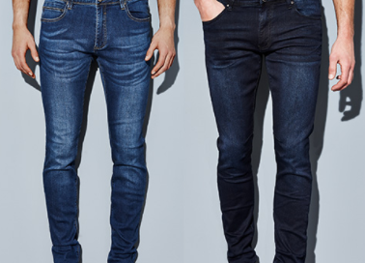

* COTTON TROUSERS: FORMAL

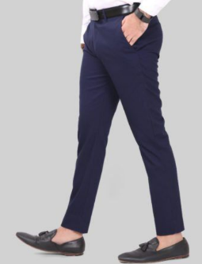

---WOMEN

* RAYON PLAZO/UMBRELLA PLAZO

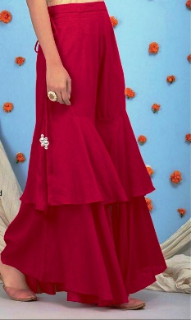

* COTTON PLAZO

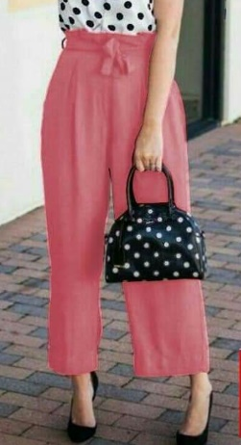

* DENIM/JEANS

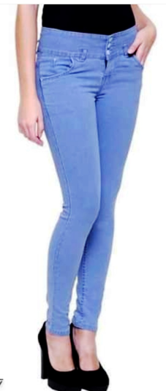

* LEGGINGS

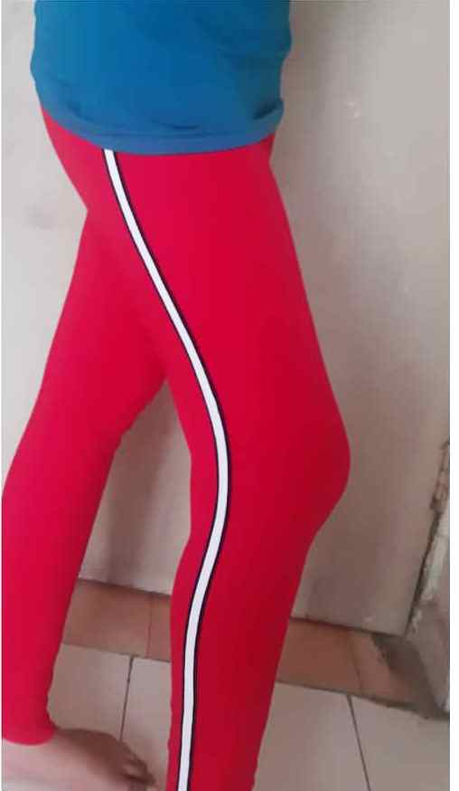

* DENIM JEGGINGS



* COTTON JEGGINGS



* DENIM SHORTS



* DEMIN JOGGER



* CULOTTE

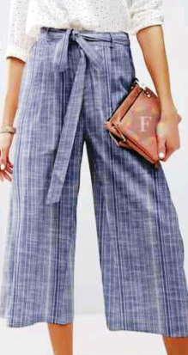

* DOUBLE CULOTTE

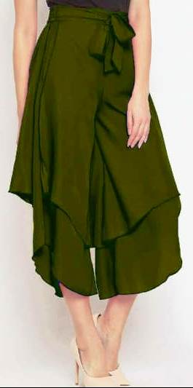

* COTTON FLARED TROUSERS

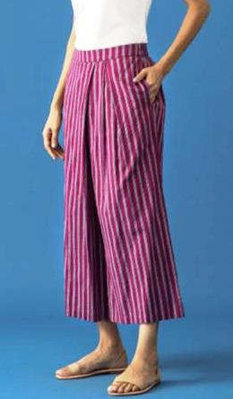

* SIGAR

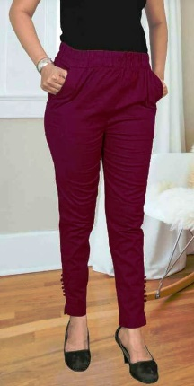

* COTTON COMFORT PANT/WEEKDAY PANT

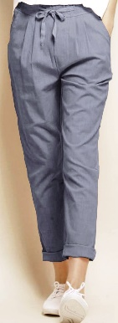

* NICKEL PANT

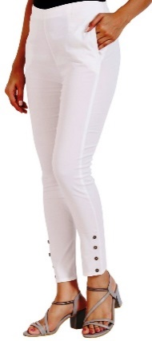

-PRIVACY POLICY

---